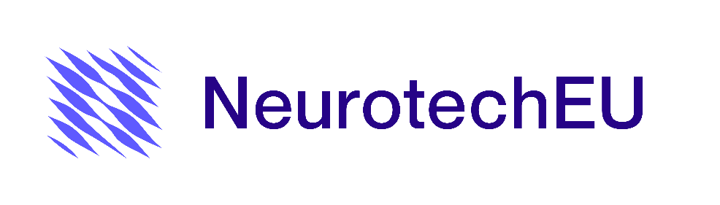

Application Form for a Place in a NeurotechEU Activity

Title of the activity:
……………………………………………………………………………………………………………………………….
……………………………………………………………………………………………………………………………….…………………………….
Host University: ………………………………………………………………………………………………………………..………………….
Dates: ……………………………………………

Name and surname:
DNI/Passport:
E-mail:
Phone:
Social media user:
Indicate the degree you are pursuing:
Bachelor student ☐ Master student ☐ PhD student ☐
Study program you are enrolled in: ……………………………………………………………………………………………………………..

Field of research (for PhD students): …………………………………………………………………………………………………………..
Academic record attached: Yes ☐ No ☐
Are you a beneficiary of a competitive fellowship (for PhD students)* Yes ☐ No ☐
Are you a member of Synapses Club: Yes ☐ No ☐

Please write a brief description (max 500 words) detailing your motivation for participating in this activity, explaining how it will benefit your training, and specifying the contribution of neuroscience and neurotechnology to your current field of study or research. The assessment of your letter of motivation will account for 50% of the total points when selecting candidates.

When sending the application, it is important to attach the required documents:

a) Photocopy of the National Identity Document, Passport or Certificate of Residence.
b) Academic and professional Curriculum Vitae. Be aware that we can ask for additional documents to prove the achievements mentioned in your CV or your motivation letter.
c) Photocopy of the registration for the bachelor's or master's degree you are currently enrolled in at UMH.
d) Photocopy of your academic transcript (in your authenticated access, you will find an unofficial extract, which is useful for us).
e) If necessary, attach your competitive fellowship application.

By submitting this application, the applicants declare under their responsibility that:

a) They meet the requirements established to participate in this activity and have the documents to accredit it if NeurotechEU requires.
b) All the data in the application conform to reality and they have the documents that accredit it if required by NeurotechEU.
c) They accept that the inaccuracy of the declared circumstances entails the denial or revocation of their participation in the activity.

Electronically signed the applicant:

